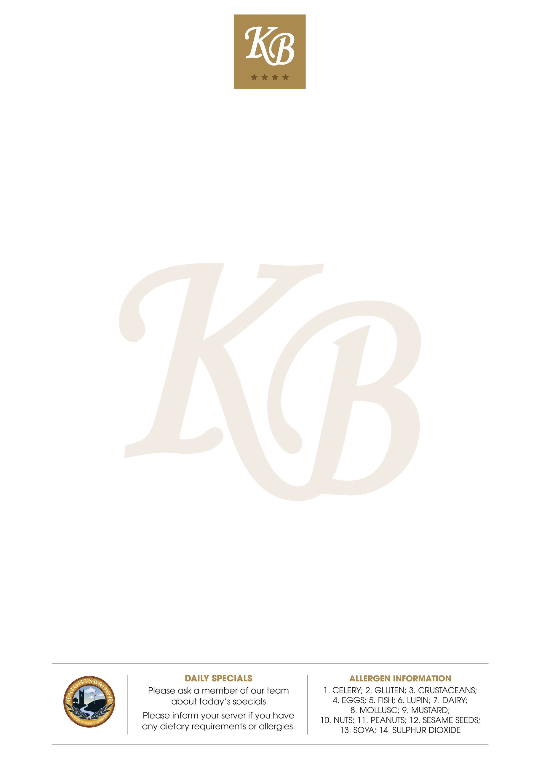

STARTERS
Choice of Soup of the day €5.50
with Brown Bread or a Roll (1.2.7)

East Coast Chowder €8.50
With Soda Bread (1.2.7.14)

Classic Chicken Salad €8.00
with Baby Gem Padano Cheese
Croutons and Grilled Chicken (2.4.5.9)

Spiced Wings €9.50
Blue Cheese Dip and Celery (1.2.4.7.9)

BBQ Wings €9.50
Blue Cheese Dip and Celery (1.2.4.7.9)
MAINS
Terrace Organic Beef Burger- €17.50
John McLaughlins Burgers Beef Brioche Bun
Relish Cheese and Bacon (1.2.4.7.9.14)

Chicken Pretzel Burger €16.50
Spicy Slaw Tomato
Leaves Fries and Garlic Dip (1.2.4.7.9.14)

Beer Battered Fish and Chips €18.00
Tartare Sauce, Crushed Peas and Lemon (1.2.5.7.14)

Linguine Primavera €15.00
Roast Cherry Tomato, Roasted Vegetables,
Basil, Parsley and Rocket (VEGAN) (1.2.4.9.14)

Macaroni and Cheese €14.00
3 Cheese Sauce, Scallions,
Garlic Toast and Side Salad (1.2.4.7.9)

Roast of the Day €15.00
With Creamed mash, Veg,
Stuffed Yorkshire Pudding and Gravy (1.2.4.7.9)

Special of the Day – Please ask your Server €15.00
1-Celery; 2-Gluten; 3-Crustaceans; 4-Eggs; 5-Fish; 6-Lupin; 7-Dairy;
8-Mollusc; 9-Mustard; 10-Nuts;
11-Peanuts; 12-Sesame Seeds; 13-Soya; 14- Sulphur Dioxide

SANDWICHES

1 Filling Closed Sandwich on White or Brown Bread €5.00
2 Filling Closed Sandwich €6.00
3 Filling Closed Sandwich €7.00
EXTRA FILLINGS €1.00
Choose From –
Ham, Beef, Chicken, tuna, Salad, Egg,
Cheddar, Tomato, Red
Onion, Bacon or Lettuce

Ploughmans Ciabatta Sandwich €10.00
Baked Ham, Cheddar, Pickles and Leaves
with Chips or Soup(1.2.7.9.14)

Southern Fried Chicken Wrap €10.00
Cos, Parmesan, Croutons and Caeser Sauce
with Chips or Soup(2.4.7.9)

Bacon Lettuce and Tomato Wrap €10.00
Mayo and Relish
with Chips or Soup (2.4.7.9.14)

Smoked Salmon Bagel €11.50
Cream Cheese, Chives and Lemon
with Chips or Soup (2.3.4.5.7.9)

Knightsbrook Club Sandwich €13.50
Bacon Chicken Lettuce and Tomato Mayo
with Chips or Soup (2.4.7.9.14)

SIDES

Chunky Fries €3.75
Skinny Fries €3.00
Side Salad €3.00
Vegetables €3.00
Mashed Potatoes €2.50
1-Celery; 2-Gluten; 3-Crustaceans; 4-Eggs; 5-Fish; 6-Lupin; 7-Dairy;
8-Mollusc; 9-Mustard; 10-Nuts;
11-Peanuts; 12-Sesame Seeds; 13-Soya; 14- Sulphur Dioxide

DESSERTS
Chocolate Brownie Sundae (2,4,7,10) €6.00
Vanilla Ice Cream, Chocolate Sauce and Whipped Cream
Cheesecake of the Day (2,4,7) €6.50
Please ask your server for today's choice
Eton Mess (2,4,7) €6.00
Choux Bun Meringue, Cream, Strawberries and Chocolate Sauce
Selection of ice cream and Sorbet (2,4,7) €6.00
Topped with Warm Chocolate Sauce and Cream
Raspberry and Cherry Compote (2,4,7) €4.50
With Cream, Biscuit and Custard
Caramel Panna Cotta (2,4,7) €4.50
with Cream and Fresh Berries

Gluten Free Desserts
Warm Pear and Almond Tartlet (4,7,10) €6.50
With Crème Anglaise and Vanilla Ice-Cream
Carrot Cake (4,7,10,14) €6.50
With Fresh Cream and Mango Coulis
Chocolate Brownie (4,7,10) €6.50
Topped with Warm Chocolate Sauce and Vanilla Ice-Cream

Our gluten free desserts are supplied by Rosaleen’s Kitchen who is certified
by the Coeliac Society of Ireland

HOT BEVERAGES

Americano €2.50(s) €3.00(med) €3.25(lge)
Cappuccino €2.85(s) €3.00(med) €3.50(lge)
Latte €3.50
Flat White €3.50
Espresso €3.00
Double Espresso €3.15
Mocha €3.70
Hot Chocolate €3.70
Tea €2.50
Knightsbrook Herbal Teas €3.75

1 – Celery; 2 – Gluten; 3 – Crustaceans; 4 – Eggs; 5 – Fish; 6 – Lupin; 7 – Dairy;
8 – Mollusc;9 – Mustard; 10 – Nuts;
11 – Peanuts; 12 – Sesame Seeds; 13 – Soya; 14 – Sulphure Dioxide

